# CS 255 System Design Document

## UML Diagrams

### UML Use Case Diagram

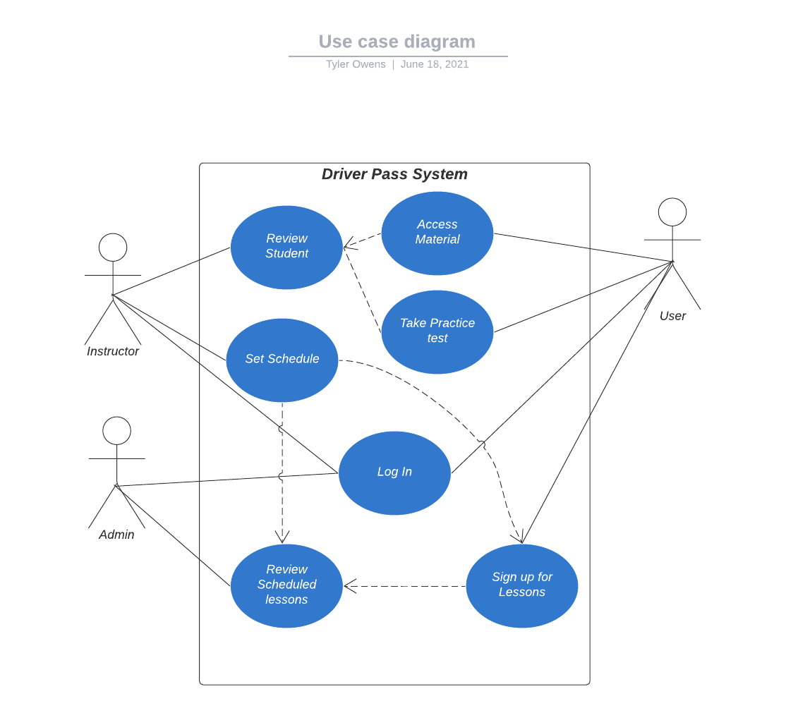

### UML Activity Diagrams

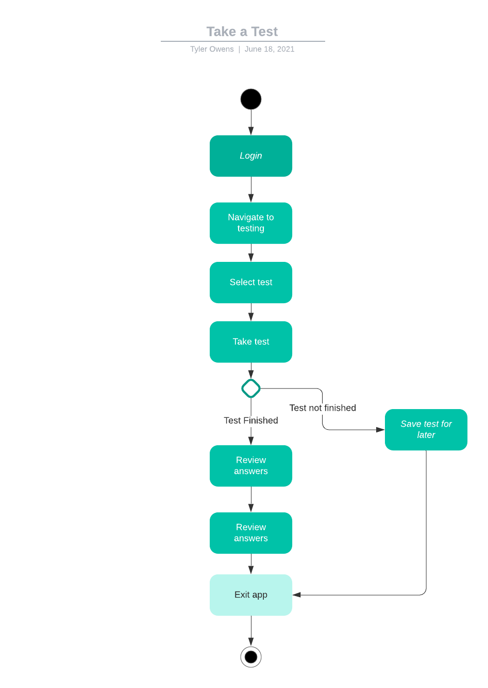

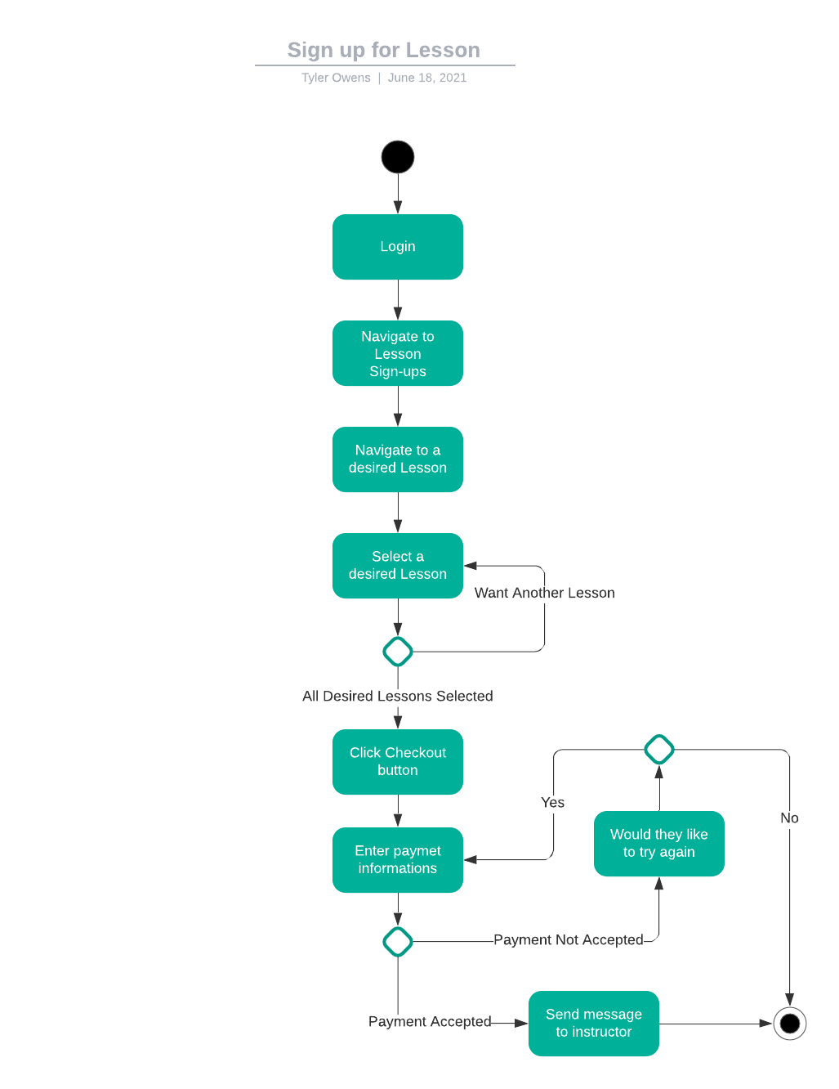

### UML Sequence Diagram

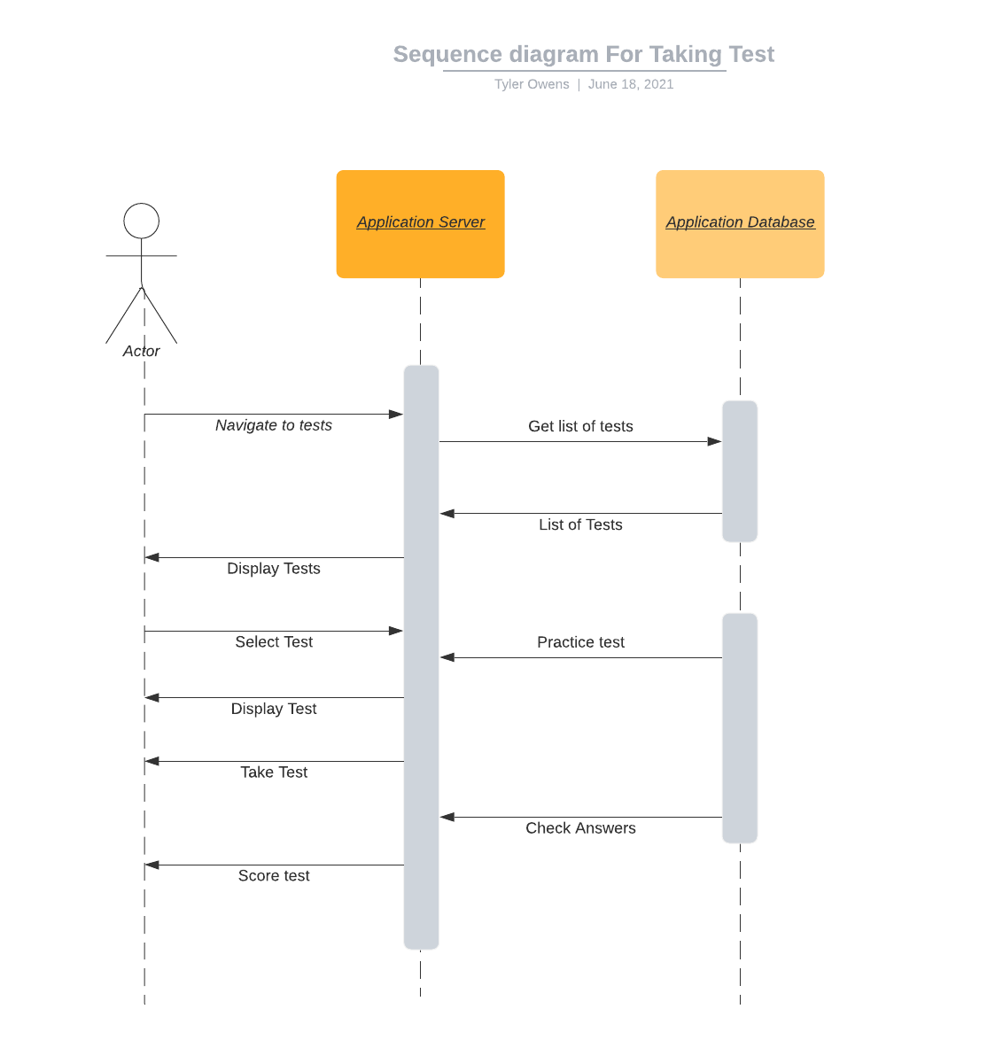

### UML Class Diagram

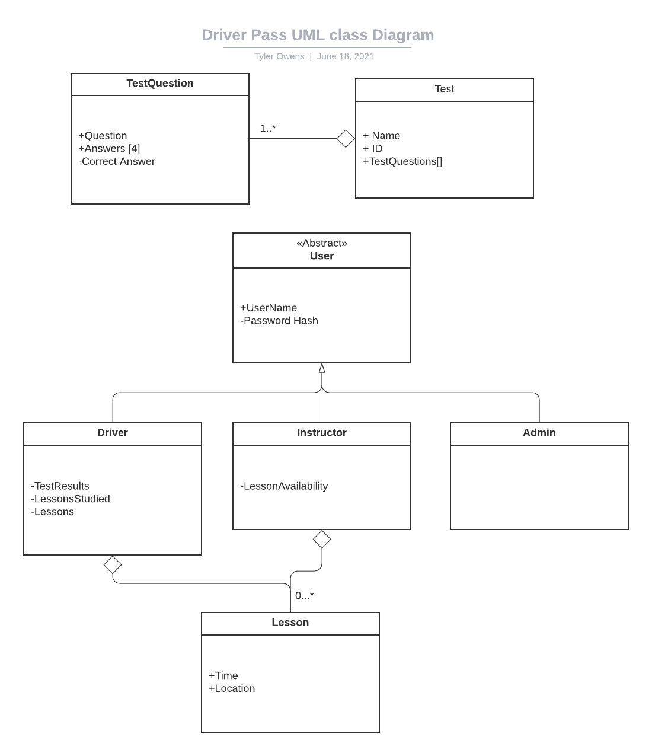

## Technical Requirements

* Cloud Based Application Server(AWS): We can run every client request through a cloud based server, this would allow us to only pay for what we use and scale quickly and cheaply based on demand.
* Cloud Based Database(AWS): It's much cheaper to store information on cloud storage and have the web servers pull information as they need it. This would also allow us to create the Database and application in such a way that material can be added, edited and removed without changing any source code.
* Domain for website: We will need a place where customers can download different client side applications. We will need to design for mobile and PC.